Objective Questions:

1 **What is the total no. of tables present in the data?**

Ans There are 2 tables:

1. Raw Data

(b) Country Description

2 **What is the total no. of attributes present in the data?**

Ans - The 'Raw Data' table has 20 attributes.

3 **How many categorical columns are there in the data? [Search about categorical and continuous data, and try to answer this question]**

**Ans**  - The 'Raw Data' table includes 12 categorical columns:

- RestaurantName

- City

- Address

- Locality

- LocalityVerbose

- Cuisines

- Currency

- Has_Table_booking

- Has_Online_delivery

- Is_delivering_now

- Switch_to_order_menu

- Datekey_Opening

4 **The data consists of some inconsistent and missing values so ensure that the data used for further analysis is cleaned.**

Ans Handling inconsistent and missing value scan de done using these techniques:

- Removing duplicates

- Handling missing values (e.g., using mean, median, or imputation)

- Data normalization

- Data transformation

**5 Using the LookUp functions, fill up the countries in the original data using the country code.**

Ans Filling up country names using country codes with VLOOKUP:

=VLOOKUP(A2, CountryCodes, 2, FALSE)

- Where A2 contains the country code, 'CountryCodes' is the range with country codes and names, and 2 is the column index of the country name.

6 **Create a table to represent the number of restaurants opened in each country.**

Ans Creating a table to represent the number of restaurants in each country:

|  |  |
| --- | --- |
| **COUNTRY** | **COUNT OF RESTAURANT** |
| India | 8652 |
| Australia | 24 |
| Brazil | 60 |
| Canada | 4 |
| Indonesia | 21 |
| New Zealand | 40 |
| Philippines | 22 |
| Qatar | 20 |
| Singapore | 20 |
| South Africa | 60 |
| Sri Lanka | 20 |
| Turkey | 34 |
| United Arab Emirates | 60 |
| United Kingdom | 80 |
| United States of America | 434 |

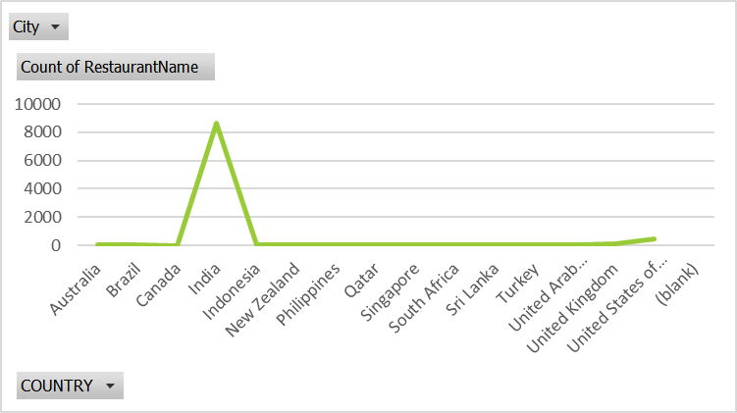

**7 Also, the management wants to look at the number of restaurants opened each year, so provide them with something here.**

Ans Number of restaurants opened each year:

- Extract the year from Datekey_Opening and creating a Pivot Table to count restaurants by year.

|  |  |
| --- | --- |
| 2010 | 1080 |
| 2011 | 1098 |
| 2012 | 1022 |
| 2013 | 1061 |
| 2014 | 1051 |
| 2015 | 1024 |
| 2016 | 1027 |
| 2017 | 1086 |
| 2018 | 1102 |
| **Grand Total** | **9551** |

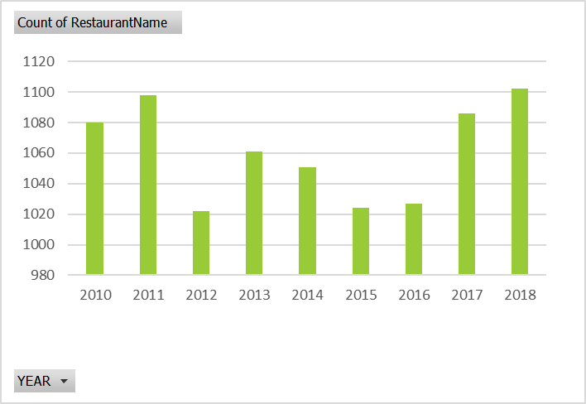

8 **What is the total number of restaurants in India in the price range of 4?**

Ans Total number of restaurants in India within the price range of 4:

- Use PivotTable to filter the data and find the count of restaurants.

|  |  |
| --- | --- |
| **Price_range** | **4** |
| **CountryName** | **India** |
| **Count of RestaurantID** | **388** |

9 **What is the average number of voters for the restaurants in each country according to the data ?**

Ans Average number of voters for restaurants in each country:

- Creating a Pivot Table to find the average of votes.

|  |  |
| --- | --- |
| **Row Labels** | **Average of Votes** |
| Australia | 111.4166667 |
| Brazil | 19.61666667 |
| Canada | 103 |
| India | 137.212552 |
| Indonesia | 772.0952381 |
| New Zealand | 243.025 |
| Philippines | 407.4090909 |
| Qatar | 163.8 |
| Singapore | 31.9 |
| South Africa | 315.1666667 |
| Sri Lanka | 146.45 |
| Turkey | 431.4705882 |
| United Arab Emirates | 493.5166667 |
| United Kingdom | 205.4875 |
| United States of America | 428.2211982 |
| **Grand Total** | **156.9097477** |

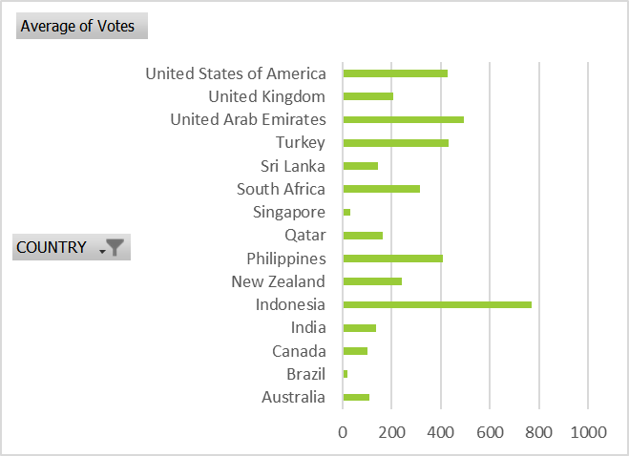

10 **Calculate the average rating for all the restaurants that have price_range < 4 and provide online delivery. Use only the “IF” function, Logical Operators, and Aggregation functions to solve this problem. [Note: Don’t use Conditional aggregation in this question.]**

Ans - Use a formula to calculate the average rating:

“ =IF(AND(Q4 < 4, N4 = "Yes"), T4, NA()) “

- Then, use the average function:

“=AVERAGE(X:X)”

- The average rating is: **3.27381151**

11 **Using Conditional formatting, highlight the rows of restaurants**

**located in the countries or cities you have suggested to the**

**management for opening new restaurants.**

Ans Highlighting rows with new restaurant suggestions using

Conditional Formatting:

- Apply Conditional Formatting with a formula to check specific cities:

“ =OR(AND($B2="Wellington", $C2="New Zealand"), AND($B2="Ankara", $C2="Turkey"), AND($B2="Flexton", $C2="Australia"), AND($B2="Forest", $C2="Australia")) “

12 **Create a new customized price column that consists of the abbreviation /symbol of the currency along with the Average_cost_for_two values. [Use string operations to do this task]**

Ans Identify the Currency Column:

- Ensure that there is a column containing the currency abbreviation

or symbol (e.g., "INR", "$"). For instance, this might be in column H.

Identify the Average Cost Column:

- Confirm that there is a column listing the average cost for two people

(e.g., 500). For example, this could be in column G.

Insert a New Column:

- Add a new column immediately to the right of the average cost

column, which we'll name "Customized Price" and place in column I.

Use a Formula to Combine Currency and Cost:

- In the first cell of the new column (e.g., I2), enter the following formula:

`=H2 & " " & G2`

- This formula combines the currency abbreviation or symbol with the

average cost for two people, separated by a space.

Drag the Formula Down:

- To apply this formula to the entire column, click the small square at the bottom-right corner of the cell with the formula and drag it down to fill the column with the formula.

13 **How can you create an array formula in Excel or Google Sheets to count the number of restaurants listed that do not offer online delivery, are in the lowest price range, and have an average cost for two people less than or equal to 250 Indian Rupees?**

Ans Counting restaurants without online delivery in the lowest price range:

- Use an array formula :

“ =SUM(($N$2:$N$9552="No")*($Q$2:$Q$9552=1)*($S$2:$S$9552<=250)*($L$2:$L$9552="INR")) “